Dynamic Time Warping Application – Diagnosis of Reactor Systems
Module 2 – Portfolio Milestone

Andrew J. Cunningham
Colorado State University Global Campus
CSC506 – Design and Analysis of Algorithms
Dr. Brian Holbert
30 March 2025

Introduction and Overview
For this portfolio project I am going to study, and implement, a Dynamic Time Warping (DTW) application to study ex-neutron fluctuations from a nuclear reactor. I chose this project initially out of a desire to study something totally new. From the list of projects I selected the one that I know absolutely nothing about, and researched the CSU Global library for research papers pertaining to the subject. A paper on reactor safety immediately jumped out at me because I am a subject matter expert on US Navy nuclear propulsion plant operations and maintenance from my time as a Submarine Officer. I know a lot about reactor theory, dynamics, and safety, so the opportunity to learn new algorithms and apply them in this subject matter immediately caught my interest.
The research paper applies DTW and backtracking to predict reactor failure criteria based on ex-core neutron signal noise fluctuations (Jeong et al., 2024). This is a natural application for the algorithm as training data is sparse given the complexity of interconnecting parts in a nuclear reactor and the lack of training data. Broadly speaking, there is no “baseline” set of data that can be applied to all reactors, so applying AI and ML models to reactor safety will always be inherently challenging.
This project will have many challenges and consist of several steps. I have to research and create a dataset, apply FFT, and create a “baseline” dataset, then I have to create a separate dataset with predictable errors, all with reasonable tolerances and assumptions. Then I have to apply DTW to create a result for the deviation then use backtracking to assess this deviation. Lastly I have to compare the results with the expected value.

What is Dynamic Time Warping?
I selected this project because DTW is a new term that I haven’t encountered in previous study, so my first step was to understand exactly what it is and how it applies to this project. To summarize the introduction provided by Jeremy Zhang, DTW is a method to compare arrays of dissimilar lengths (Zhang, 2020). As illustrated in figure 1, analysis of two different plots can be difficult if the data only loosely follows the same pattern, but varies in magnitude, direction, and phase. Euclidian matching is the process of comparing vertical axis deviations for each horizonal input, but if the “shapes” don’t line up perfectly, then the Euclidian comparison will come up short, and not contain the real truth. DTW is a process of allowing fluctuations in input values by applying a one-to-many match so that the local maxima and minima are allowed to follow similar patterns.
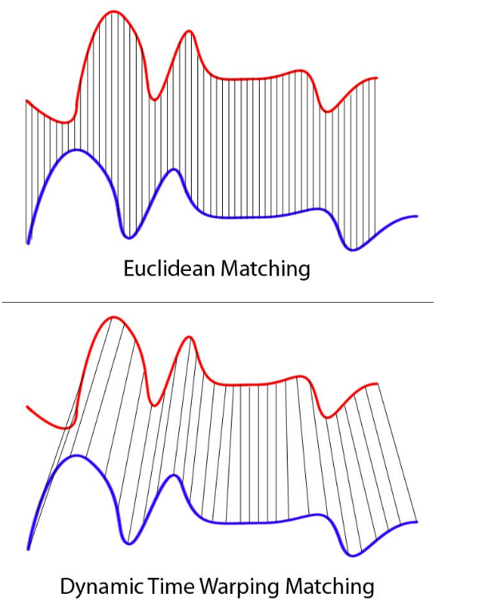
Figure 1 - Comparison of Euclidian Matching and DTW (Zhang, 2020).

What is Backtracking?
From the Medium, backtracking is the general algorithm that incrementally builds solutions using partial candidates, saving progress, and “backtracks” to as soon as a potential candidate is doesn’t meet success criteria (Iacono, 2017). A simple example of it is finding the solution to a puzzle by starting at “end” and working towards “begin,” “backtracking” if a dead end is met. In this project I’ll be using backtracking in conjunction with DTW. The two algorithms will be used together in this project to create a detailed map of where and how signals diverge to create points of where anomalies occur. This also helps with visualization.

Project Plan
The following steps will be completed by me, Andrew Cunningham, and have sequential deadlines such that the information can be used to build the next steps. The timeline aligns with project milestones.
- Simulate datasets
  - Find, or derive, a formula for simulating neutron noise and generate a baseline dataset.
  - Determine variables to simulate cases that would trigger failure criteria and create a separate dataset containing the scenarios.
  - For this project I don’t need to simulate data from the nuclear instruments, I can just create data on the signals generated
  - Make sure to include fluctuations in the amplitude, phase, and frequency.
- Preprocess signals by applying FFT to get magnitude spectra for the baseline and faulted scenarios.
  - I need to research this more and see if this step can be abstracted away. It might be outside the scope of the course as I’m not working with raw data, I can simulate processed signals away.
  - TODO: research implementation of FFT and determine if necessary.
- Implement DTW and apply to both baseline and faulted scenarios.
  - Build a dataset of the global distances from the expected vs actual signal fluctuations
- Implement backtracking to create a visualization of deviations.
- Evaluate results to compare DTW results with known deviations and assess the performance of my algorithm.
- Visualize the results.

References
Iacono, A. (2017, October 7). Backtracking explained. Medium. https://medium.com/@andreaiacono/backtracking-explained-7450d6ef9e1a#:~:text=Backtracking%20is%20a%20general%20algorithm,completed%20to%20a%20valid%20solution.
Jeong, H., Kim, J., Jung, D., & Kwon, J. (2024, December 9). Deep-Learning and Dynamic Time Warping-Based Approaches for the Diagnosis of Reactor Systems. Sensors Journal. https://www.mdpi.com/1424-8220/24/23/7865
Zhang, J. (2020, February 1). Dynamic time warping. Towards Data Science. https://towardsdatascience.com/dynamic-time-warping-3933f25fcdd/

